* Invoke a PowerShell Command or Script from Outside PowerShell
* To invoke a PowerShell command, use the –Command parameter:

**PowerShell -Command Get-Process; Read-Host**

* To launch a PowerShell script, use the -Fileparameter:

**Syntax** - PowerShell -File 'full path to script' arguments

For example:

**PowerShell -File 'c:\shared scripts\Get-Report.ps1' Hello World**

* To save your command history to a file, pipe the output of Get-History to the ExportCliXmlcmdlet:

**Get-History | Export-CliXml Filename**

**Get-History | Select –Last 100 | Export-CliXml Filename**

* Toadd a previously saved command history to your current session history, call the Import- CliXmlcmdlet and then pipe that output to the Add-Historycmdlet:

**Import-CliXml Filename| Add-History**

**Get-History 65,66 | Format-Table \***

* Interactively View and Process Command Output
* If you want to analyze the output of command so the solution is the use the **Out-GridView** cmdlet to the output command
* The Out-GridView is the one of the powerShell cmdlets that displays a graphical user interface
* While the Where-Object and the Sort-Object are commonly used to the sort and the filter the list of items
* But the **Out-GridView** provide the built-in facilities to the sorting and filtering facilities by the adding a **Add Criteria**
* **See the step by step to how to ssorting and filtering**
* **First**, write the  in cmdlets
* So open the Out-GridView window **Show in Figure**

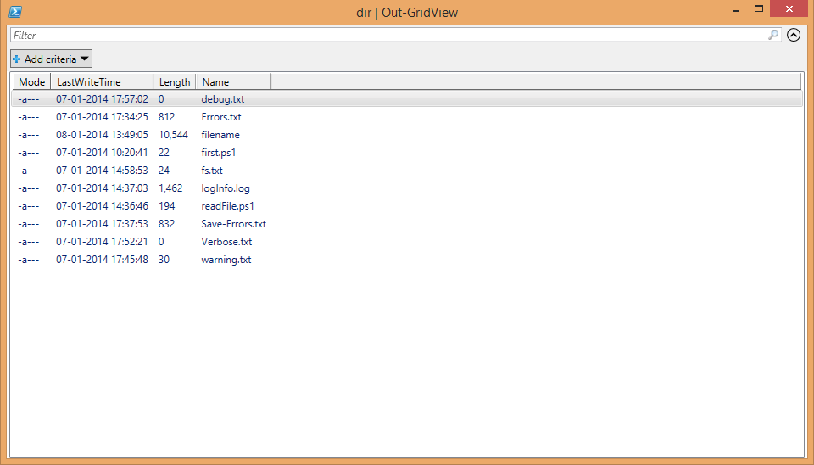

* After the apply to criteria filter to the select the **Add criteria** Button and select a column to which filter on (like here we select the Name Field)
* And Out-GridView also provide several operation whose perform on filter field
* Several Operation are see in the figure we select the **starts with** operation

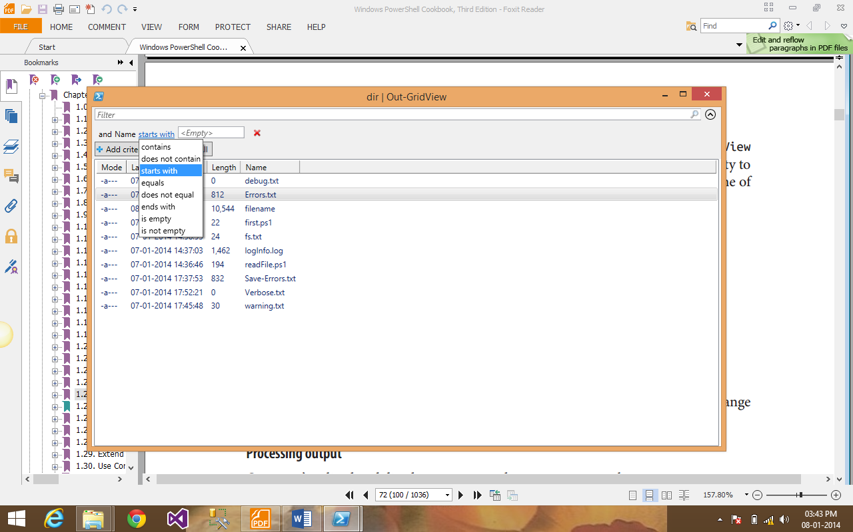

* After the select the operation then see the output

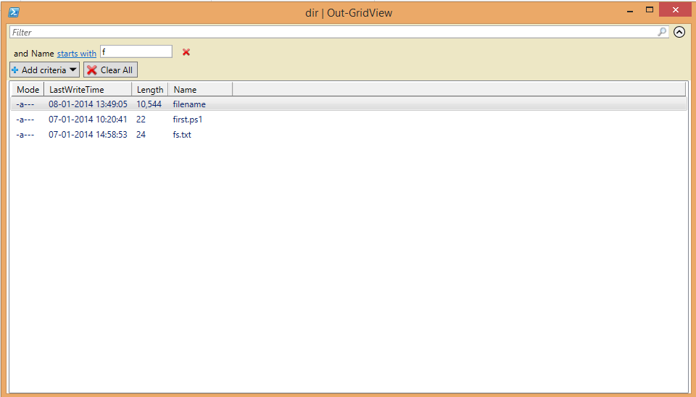

* Strore the output of a command into a File
* To Redirect the output command into file is the two way

1. Out-File
2. and Redirection Operator

**Out-File :**

**Example:-**

* Get-ChildItem | Out-File unicodeFile.txt
* Get-ChildItem | Out-File -Width 120 unicodeFile.cs
* Get-ChildItem | Out-File -Append files.txt

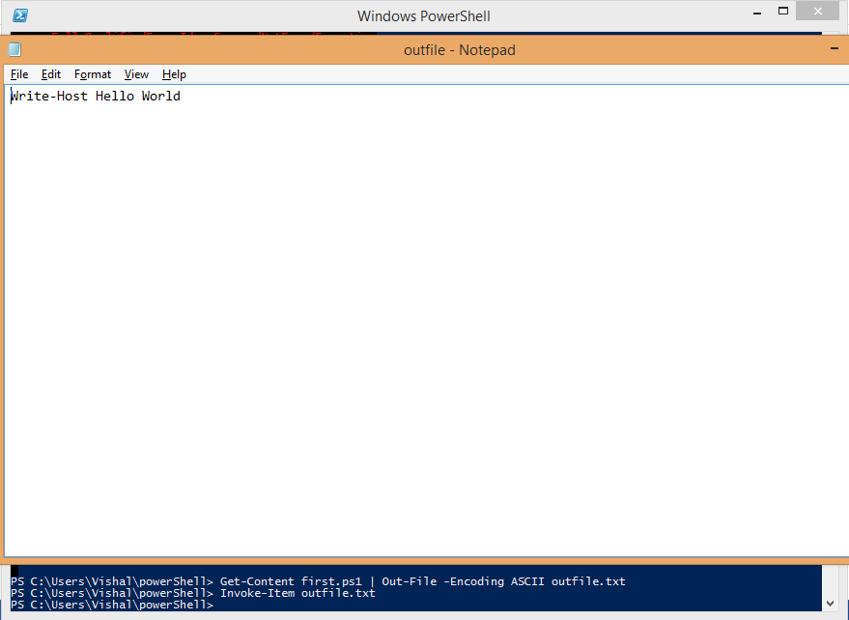

**Redirection Operators :**

**Examples**

* Get-ChildItem 2> errors.txt
* Get-ChildItem n> otherStreams.txt
* Get-ChildItem >> files.txt

